

COIT20258 Software Engineering (HT2, 2026)

Tutor/Lecturer: Dr. Meiru Che

Assessment 1: Case Study

Disaster Response System (DRS): Requirements and Architecture Specification

Prepared by: Wilson Vergara
Student ID:12302173

Table of Contents
1. Introduction 3
1.1 Overview 3
1.2 System Users 3
1.3 System Usability 3
1.4 Operational Constraints 4
2. Context Model 4
2.1 Context Boundary Description 4
3. Use Cases 5
3.1 UC-1: Report Disaster Incident 5
3.2 UC-2: Assess and Prioritise Report 6
3.3 UC-3: Coordinate Inter-Department Response 6
3.4 UC-5: Update Task Status 7
3.5 UC-6: Issue Public Warning 7
4. Use Case Diagram 8
5. System Requirements 9
5.1 Functional Requirements 9
5.2 Non-Functional Requirements 9
6. User Requirements 10
6.1 User Stories 10
6.2 Consolidated User Requirements 11
7. Sequence Diagrams 12
7.1 Sequence Diagram 1 - Report Disaster Incident (UC-1) 12
7.2 Sequence Diagram 2 - Assess and Dispatch (UC-2 and UC-3) 13
7.3 Participating Objects 13
8. System Architecture (MVC) 14
8.1 Component Responsibilities 14
9. GUI Design 15
9.1 Layout 1: Citizen Disaster Reporting Interface 15
9.2 Layout 2: Dispatcher Command and Coordination Dashboard 16
10. Conclusion and Reflection 16
10.1 Summary of Identified Requirements 16
10.2 Reflection on Usability 16
11. References 17

1. Introduction

1.1 Overview
Disaster response involves several core activities, including early warning, evacuation, search and rescue, emergency aid, damage assessment, and infrastructure repair. The specific tasks needed depend heavily on the nature of the event. For instance, responding to a hurricane involves assessing structural damage, clearing debris, repairing roads or maritime assets, and managing public health risks.
The Disaster Response System (DRS) is a multi-tiered software application designed to manage and centralize these emergency operations. Table 1 outlines the core objectives of the system.
# | Objective
O-1 | Allow users to report different types of disasters, such as hurricanes, fires and earthquakes.
O-2 | Provide quick and accurate assessments of reported disasters and generate prioritised responses accordingly.
O-3 | Coordinate different departments and personnel for efficient and effective disaster responses.
Table 1 - System objectives

1.2 System Users
The DRS serves multiple stakeholder groups across public and organisational sectors. Each group interacts with a distinct subset of system functionality and is governed by a separate access role.
User group | Responsibilities within the DRS | Access role
Public Citizens / Reporters | Report disaster events, submit location and severity details, and view official status updates and announcements. | ROLE_PUBLIC (unauthenticated / self-registered)
Response Controllers / Emergency Dispatchers | Review incoming disaster reports, verify system-generated priority scores, and assign response tasks. | ROLE_CONTROLLER
Field Responders | Receive dispatch commands and update task progress on-site. | ROLE_RESPONDER
External Organisation Coordinators | Coordinate departmental resources and communicate task acceptance back to the DRS. | ROLE_AGENCY
Table 2 - Stakeholder groups and system responsibilities

1.3 System Usability
Because the DRS will be used during high-stress crisis situations, its user interface must prioritize speed, clarity, and reliability
- Simplified Navigation: The interface uses simple workflows so users can enter critical data quickly without unnecessary steps.
- Visual Priority Cues: Urgent events are highlighted using color-coded priority levels to make critical incidents instantly visible to operators.
- Immediate Confirmation: Citizens receive an instant visual confirmation and a unique tracking ID as soon as a report is submitted, reassuring them that their entry was received.

1.4 Operational Constraints
Constraint | Description
Availability and reliability | The system must provide continuous 24/7 availability during major crisis events.
Security and confidentiality | Access to sensitive operational data must be restricted using role-based access control (RBAC), and all communications must be encrypted.
Interoperability | The system must maintain clearly defined external interfaces to exchange data with external organisation systems.
Table 3 - Operational constraints

2. Context Model
The context model defines the operational boundaries of the DRS, distinguishing internal system features from external third-party systems. Core functions including user authentication, incident parsing, risk scoring, dispatch management, and public alerts are handled directly within the DRS boundary. External partner organizations operate outside this boundary and communicate with the system through dedicated external interfaces.
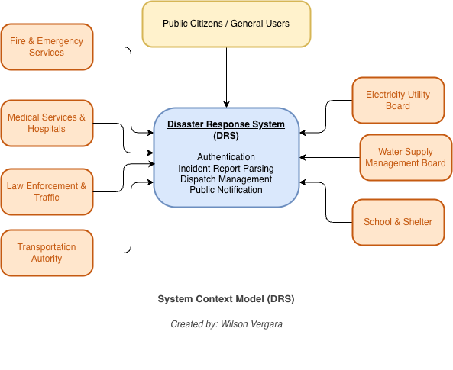
Figure 1 - System Context Model

2.1 Context Boundary Description
Boundary | Elements
Inside the system boundary | User authentication and RBAC, incident report parsing, risk score evaluation, dispatch management, and public notification services.
External entities | Fire and Emergency Services, Hospitals and Medical Services, Law Enforcement and Traffic, Transportation Authority, Electricity Utility Board, Water Supply Board, Waste Management, and Schools and Shelters.
Table 4 - Context boundary

3. Use Cases
Use cases were originally developed to support requirements elicitation and are now incorporated into the UML, with each use case representing a discrete task that involves external interaction with the system (Sommerville, 2016). Six use cases capture the end-to-end operational flow of the system, from citizen reporting through controller assessment, field task tracking and public warning, to inter-agency coordination. A summary is presented first, followed by the fully specified descriptions.
ID | Use case | Primary actor | Trigger
UC-1 | Report Disaster Incident | Public Citizen / Reporter | Citizen observes a disaster
UC-2 | Assess and Prioritise Report | Response Controller | Unverified report enters queue
UC-3 | Coordinate Inter-Department Response | Response Controller | Incident is prioritised
UC-4 | Send Department Dispatch Alert | External Coordinator | Included by UC-3
UC-5 | Update Task Status | Field Responder | Task dispatched to responder
UC-6 | Issue Public Warning | Response Controller | Incident confirmed as public-facing
Table 5 - Use case summary

3.1 UC-1: Report Disaster Incident
Use case ID | UC-1
Use case name | Report Disaster Incident
Actors | Public Citizen / Reporter (primary)
Description | A citizen reports an observed disaster event, specifying location, disaster type and situational details.
Stimulus | A citizen observes or becomes aware of a disaster.
Preconditions | The user has opened the DRS application.
Postconditions | A disaster incident record is stored in the DRS database with an "Unverified" status and a tracking ID is returned to the reporter.
Main flow | 1. The user selects the "Report Incident" option.  2. The system presents the incident report form.  3. The user selects the disaster category (for example Hurricane, Fire or Earthquake), enters the location, and provides a description.  4. The user submits the form.  5. The system validates the input, logs the entry, generates a unique incident ID, and displays a confirmation message.

3.2 UC-2: Assess and Prioritise Report
Use case ID | UC-2
Use case name | Assess and Prioritise Report
Actors | Response Controller (primary)
Description | A controller reviews an incoming incident report, verifies its details, and sets an operational priority level.
Stimulus | An unverified incident report enters the review queue.
Preconditions | Unverified incident reports exist in the queue and the controller is authenticated with ROLE_CONTROLLER.
Postconditions | The report status is updated to "Prioritised" and made available for departmental dispatch.
Main flow | 1. The controller selects an unverified incident from the queue.  2. The system displays report details along with an automated preliminary risk score.  3. The controller evaluates the details and sets the priority ranking (High, Medium or Low).  4. The system updates the incident record and enables the dispatch tools.

3.3 UC-3: Coordinate Inter-Department Response
Use case ID | UC-3
Use case name | Coordinate Inter-Department Response
Actors | Response Controller (primary), External Department Coordinators (secondary)
Description | The controller dispatches tasks to external partner agencies and tracks response coordination.
Stimulus | An incident report is prioritised and requires a coordinated response.
Preconditions | An incident report has been assessed and prioritised.
Postconditions | Dispatch notifications are transmitted to the selected external department interfaces and reflected on the command dashboard.
Main flow | 1. The controller selects a prioritised incident and initiates the dispatch workflow.  2. The system recommends partner agencies based on the disaster type (for example Fire, Hospital or Electricity).  3. The controller confirms and dispatches task requests to the selected agency interfaces.  4. External Department Coordinators receive alerts and update task acceptance statuses.  5. The system aggregates real-time updates onto the command dashboard.
Includes | UC-4: Send Department Dispatch Alert

3.4 UC-5: Update Task Status
Use case ID | UC-5
Use case name | Update Task Status
Actors | Field Responder (primary)
Description | A field responder updates the progress of an assigned dispatch task from the field, so the command dashboard reflects the true situation on the ground.
Stimulus | A dispatch task is assigned to the field responder.
Preconditions | A dispatch task has been assigned to the responder and the responder is authenticated with ROLE_RESPONDER.
Postconditions | The task status is updated (e.g. Acknowledged, En Route, On-Scene or Resolved) and the change is reflected on the command dashboard in real time.
Main flow | 1. The responder opens the assigned task on their device.  2. The responder selects a new status and optionally adds a short note.  3. The system timestamps the update and synchronises it with the incident record.  4. The system reflects the updated status on the command dashboard.

3.5 UC-6: Issue Public Warning
Use case ID | UC-6
Use case name | Issue Public Warning
Actors | Response Controller (primary)
Description | A controller broadcasts a localised emergency advisory to citizens in the area affected by a prioritised incident.
Stimulus | An incident is confirmed as requiring a public-facing warning.
Preconditions | An incident has been assessed and prioritised, and the controller is authenticated with ROLE_CONTROLLER.
Postconditions | A public warning is broadcast to citizens in the affected area and the broadcast is logged against the incident.
Main flow | 1. The controller selects a prioritised incident and chooses “Broadcast Public Warning”.  2. The system pre-fills the affected area from the incident location and severity.  3. The controller confirms or edits the advisory message and the affected area.  4. The system broadcasts the advisory to citizens in the affected area and logs the broadcast.

4. Use Case Diagram
The diagram follows the notation defined in the OMG Unified Modeling Language specification, in which actors are drawn as stick figures, use cases as ellipses, and the system boundary as an enclosing rectangle (Object Management Group, 2017). The use case diagram below shows the actors, the system boundary and the relationships between the six use cases. UC-3 includes UC-4, since every inter-department coordination action necessarily issues a dispatch alert. Field Responder is added as an actor for UC-5, and UC-6 gives the Response Controller a use case for broadcasting a public warning.
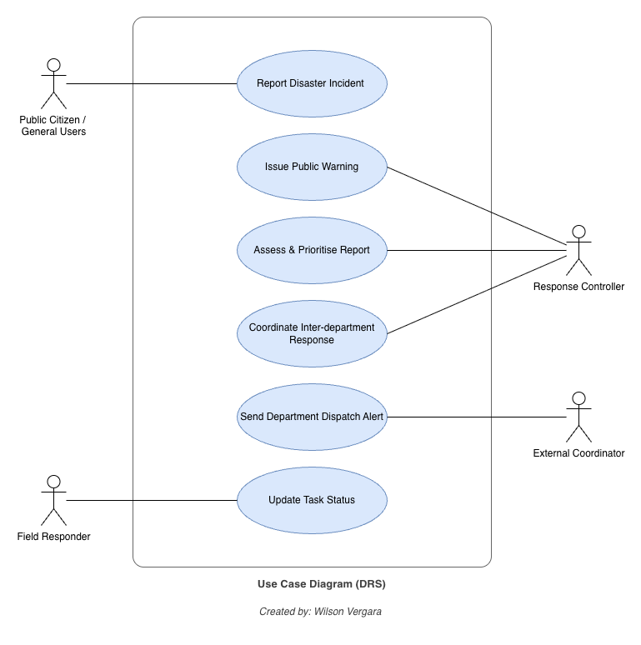
Figure 2 - Use Case Diagram

5. System Requirements

5.1 Functional Requirements
ID | Requirement | Description | Priority
FR-1 | Incident Reporting | The system shall allow users to log disaster reports containing disaster category, location, description and severity indicators. | Essential
FR-2 | Automated Risk Assessment | The system shall compute an initial severity score using disaster parameters and geographical location data. | Essential
FR-3 | Multi-Department Routing | The system shall route task notifications to external agency interfaces including Fire, Hospital, Police, Utilities and Transport. | Essential
FR-4 | Status Synchronisation | The system shall track and update dispatch states (Pending, Dispatched, On-Scene, Resolved) in real time. | Essential
FR-5 | Public Warning Broadcasts | The system shall enable controllers to broadcast localised emergency advisories to citizens. | Desirable
FR-6 | Authentication and Access Control | The system shall authenticate every user and enforce role-based access control (ROLE_PUBLIC, ROLE_CONTROLLER, ROLE_RESPONDER, ROLE_AGENCY) for every operation. | Essential
Table 6 - Functional requirements

5.2 Non-Functional Requirements
ID | Category | Requirement | Measurable target | Priority
NFR-1 | Performance | Inter-agency dispatch notifications shall be delivered to target external interfaces promptly after controller confirmation. | Under 2 seconds, 95th percentile | Essential
NFR-2 | Availability | The system shall remain operational during active regional disaster events. | 99.99% uptime per event window | Essential
NFR-3 | Security | The system shall enforce role-based access control and encrypt all stored and transmitted data. | TLS 1.3 in transit, AES-256 at rest | Essential
NFR-4 | Maintainability | The application shall follow the Model-View-Controller pattern to support modular upgrades and maintenance. | No cross-layer dependency violations | Desirable
NFR-5 | Usability | The citizen reporting interface shall let a first-time user submit a report with no more than five fields and three interactions. | ≤ 3 primary interactions; task completion ≤ 90 seconds in usability testing | Essential
Table 7 - Non-functional requirements

6. User Requirements
User requirements state high-level system services and constraints from the client's perspective, expressed in terms the client can understand and verify. They were elicited as user stories first, then consolidated into the formal user requirement statements that follow.

6.1 User Stories
Each user story is written from the viewpoint of one of the stakeholder groups identified in Section 1.2 and states the goal and the benefit that justifies it.
ID | Stakeholder | User story | Realised by
US-1 | Public Citizen | As a citizen, I want to report a disaster by selecting its type and location, so that emergency services are alerted quickly without me needing to describe technical details. | FR-1, UC-1
US-2 | Public Citizen | As a citizen, I want to receive a tracking ID as soon as I submit a report, so that I know my report was received and can follow its progress. | FR-1, UC-1
US-3 | Public Citizen | As a citizen, I want to receive localised emergency advisories, so that I know whether to evacuate or shelter in place. | FR-5, UC-6
US-4 | Response Controller | As a controller, I want incoming reports to arrive with an automated severity score, so that I can triage a large queue quickly during a major event. | FR-2, UC-2
US-5 | Response Controller | As a controller, I want to set and change the priority of an incident, so that limited resources are directed to the most severe cases first. | FR-2, UC-2
US-6 | Response Controller | As a controller, I want the system to recommend which agencies to dispatch based on disaster type, so that I do not have to remember the routing rules under pressure. | FR-3, UC-3
US-7 | Response Controller | As a controller, I want to see the live status of every dispatched task on one dashboard, so that I can identify agencies that have not responded. | FR-4, UC-3
US-8 | Field Responder | As a field responder, I want to receive my assigned task on-site and update its progress, so that the command dashboard reflects the true situation on the ground. | FR-4, UC-5
US-9 | External Coordinator | As an agency coordinator, I want to receive dispatch alerts through a defined interface and acknowledge them, so that my department can be tasked without a phone call. | FR-3, UC-4
US-10 | External Coordinator | As an agency coordinator, I want to receive only the operational details relevant to my task, so that citizen privacy obligations are not breached. | NFR-3, UC-3
Table 8 - User stories elicited from stakeholder groups

6.2 Consolidated User Requirements
The user requirements below address the categories the client is most concerned with: the type of system to be delivered, its user interface, its availability, and its response behaviour, together with continuity and confidentiality obligations.
ID | Category | Statement | Derived system requirements
UR-1 | Type of system | The client requires a multi-tiered desktop application built on the Model-View-Controller pattern, delivered as a JavaFX client for controller and responder workstations, with a lightweight reporting interface available to the public. | NFR-4
UR-2 | User interface | The client requires an intuitive interface that allows emergency staff to manage disaster operations with minimal training, using colour-coded priority indicators and a minimum number of steps per task. | FR-1, FR-4, NFR-5
UR-3 | Availability | The system must be available continuously throughout an active disaster event, with no scheduled downtime during a declared emergency. | NFR-2
UR-4 | Response | The system must respond to controller actions and transmit dispatch notifications within a few seconds, and must acknowledge a citizen report immediately with a tracking confirmation. | FR-1, FR-4, NFR-1
UR-5 | Operational continuity | The system must remain functional under heavy user loads and constrained network bandwidth during severe crises. | NFR-1, NFR-2
UR-6 | Data confidentiality | Inter-departmental data exchanges must respect privacy regulations, sharing only the operational details necessary for each agency to act. | FR-3, NFR-3
Table 9 - User requirements

7. Sequence Diagrams
Sequence diagrams are part of the UML and are used to model the interactions between actors and the objects within a system over the course of a use case (Sommerville, 2016). Two sequence diagrams model the flow of control and data through the system. The first covers the citizen-facing reporting path (UC-1); the second covers the controller-facing assessment and dispatch path (UC-2 and UC-3). Together they exercise every MVC layer and the external agency interface.

7.1 Sequence Diagram 1 - Report Disaster Incident (UC-1)
This interaction shows how a citizen report travels from the JavaFX form through validation and automated risk scoring into persistence, and how the tracking ID is returned. The alt fragment records the alternative flow in which validation fails and no incident record is created.
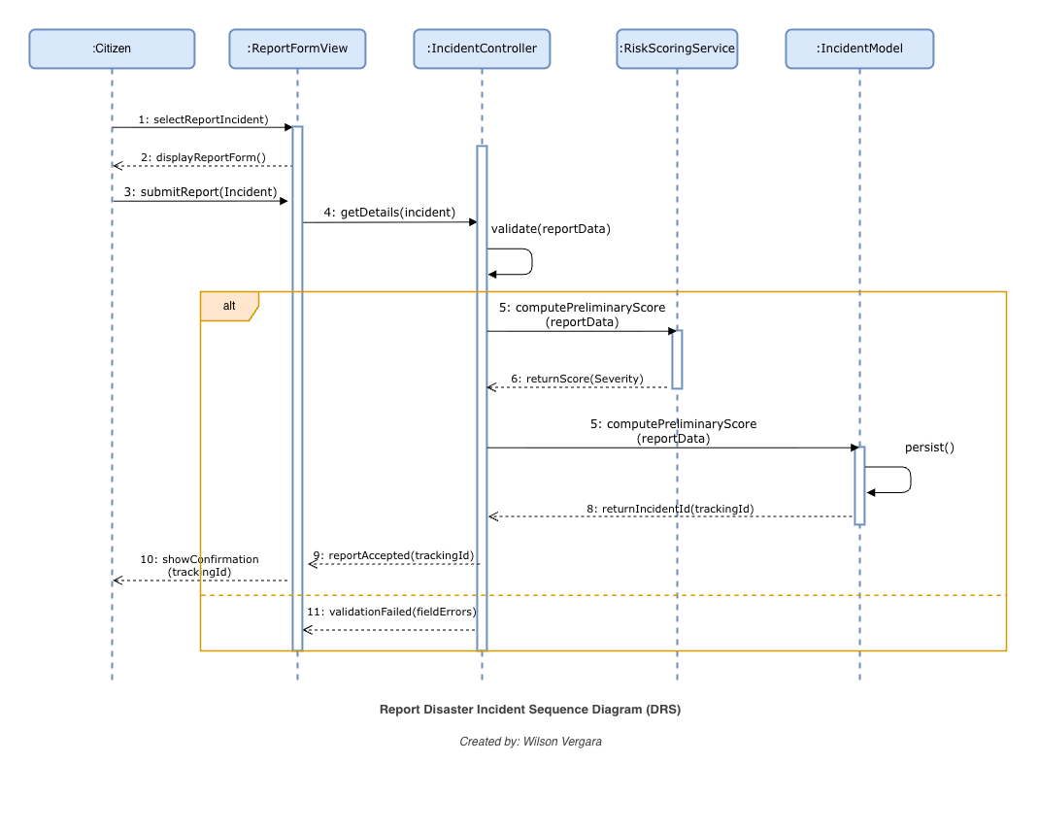
Figure 3 - Report disaster incident sequence diagram (UC-1)

7.2 Sequence Diagram 2 - Assess and Dispatch (UC-2 and UC-3)
This interaction models object collaboration over time when a Response Controller assesses an incident and dispatches tasks to external agencies. It divides into three phases: retrieval and display of incident details, prioritisation and persistence, and external acknowledgement.
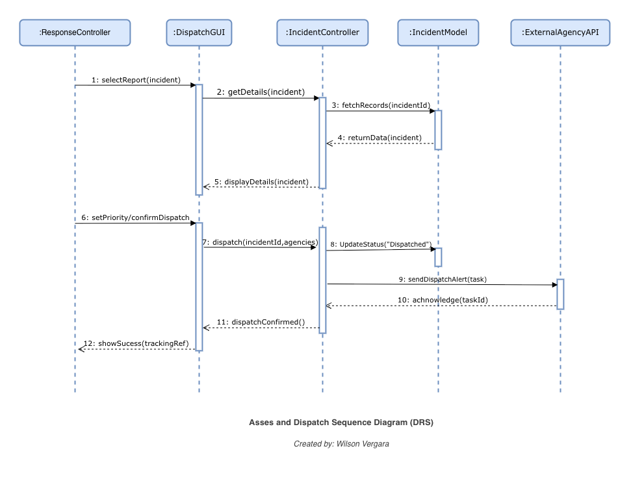
Figure 4 - Assess and dispatch sequence diagram (UC-2 and UC-3)

7.3 Participating Objects
Object | MVC layer | Responsibility
:ReportFormView | View | Renders the citizen incident report form and displays the tracking confirmation.
:DispatchGUI | View | Renders the incident detail panel and dispatch controls, and relays controller actions.
:IncidentController | Controller | Orchestrates validation, retrieval, prioritisation, persistence and outbound dispatch calls.
:RiskScoringService | Controller | Computes the preliminary severity score from disaster parameters and location data (FR-2).
:IncidentModel | Model | Holds incident state and applies persistence and domain rules.
:ExternalAgencyAPI | External interface | Receives dispatch alerts and returns acknowledgements from partner agencies.
Table 10 - Objects appearing in the sequence diagrams

8. System Architecture (MVC)
The Model-View-Controller pattern separates the presentation and interaction of a system from its data, structuring it into three collaborating components (Sommerville, 2016). The DRS uses the Model-View-Controller pattern to separate application state, business logic and presentation.
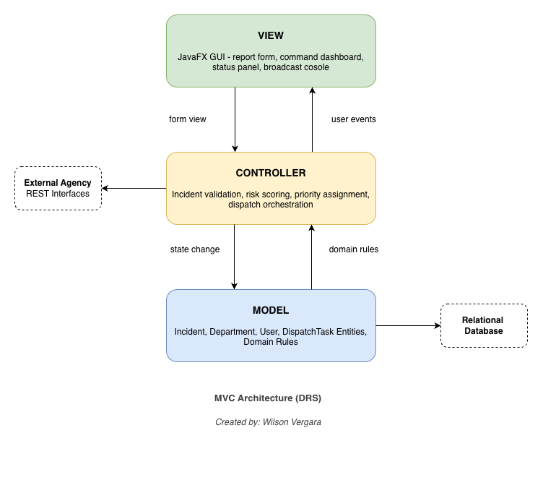
Figure 5 - MVC architecture of the DRS

8.1 Component Responsibilities
Layer | Responsibility | Representative classes
Model | Encapsulates domain logic, entity state and database persistence rules. It operates independently of the user interface. | Incident, Department, User, DispatchTask, IncidentRepository
View | Manages the graphical display (JavaFX controls, forms and dashboards) and renders state updates received from the Model or Controller. | ReportFormView, DispatchGUI, BroadcastConsole
Controller | Receives user input from the View, updates Model state, executes validation and prioritisation logic, and updates the View. | IncidentController, DispatchController, RiskScoringService
Table 12 - MVC component responsibilities

9. GUI Design
The preliminary desktop interface layouts below are designed for implementation using JavaFX Scene Builder. Both screens apply the usability principles in Section 1.3: minimal field count, colour-coded priority, and immediate confirmation feedback.

9.1 Layout 1: Citizen Disaster Reporting Interface
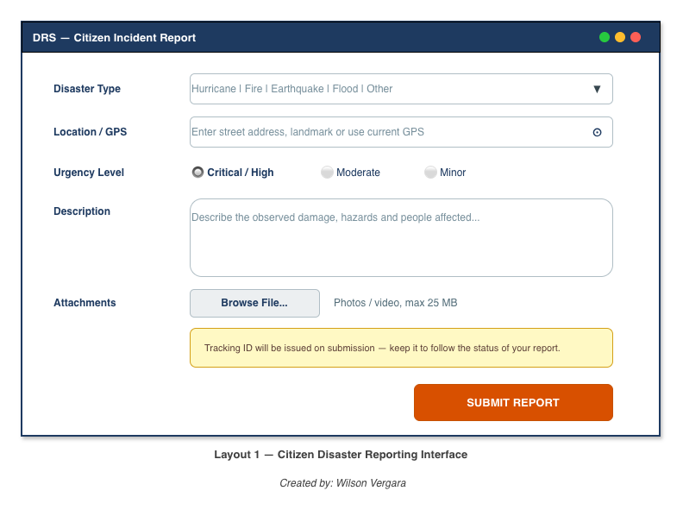
Figure 6 - Citizen incident report screen
The form is deliberately short. Disaster type and location are the only strictly mandatory fields, so a report can be lodged in seconds under duress, and the notice above the submit button sets the expectation that a tracking ID will follow immediately (UR-4).

9.2 Layout 2: Dispatcher Command and Coordination Dashboard
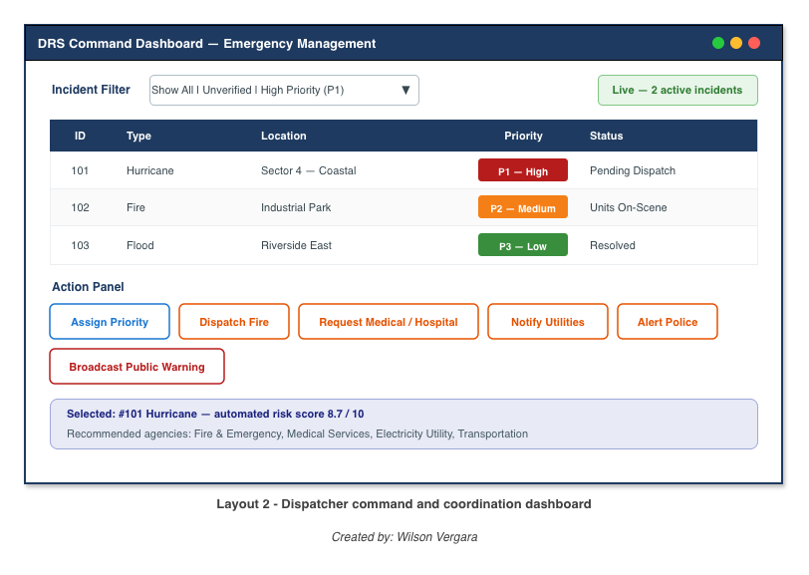
Figure 7 - Dispatcher command and coordination dashboard
Priority is rendered as a colour-coded badge rather than plain text so that a controller can triage the queue at a glance. The action panel exposes each partner agency as a single button, and the selection summary shows the automated risk score alongside the agencies the system recommends for the chosen incident.

10. Conclusion and Reflection

10.1 Summary of Identified Requirements
This document details the functional and architectural specifications for the Disaster Response System. By combining context modeling, stakeholder user stories, detailed use cases, system requirements, sequence diagrams, and an MVC architecture, the specification provides a clear design framework for emergency coordination. Ten user stories gathered across four key stakeholder groups were consolidated into six core user requirements. From these, six functional and five non-functional requirements were established.

10.2 Reflection on Usability
The user interface designs focus on clear visual hierarchy and minimal user input steps. A key challenge during design was balancing the need for detailed incident data against the necessity for quick reporting during an emergency. This was addressed by requiring only essential fields disaster type and location, while leaving remaining inputs optional for additional context.

11. References

Sommerville, I. (2016). Software engineering (10th ed.). Pearson Education.
Object Management Group. (2017). OMG Unified Modeling Language (OMG UML), version 2.5.1. OMG.

